Kk Kk

Kk Kk

Kk Kk

Kk Kk

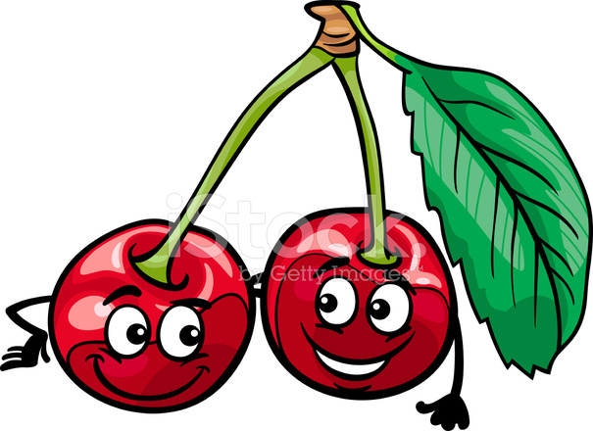 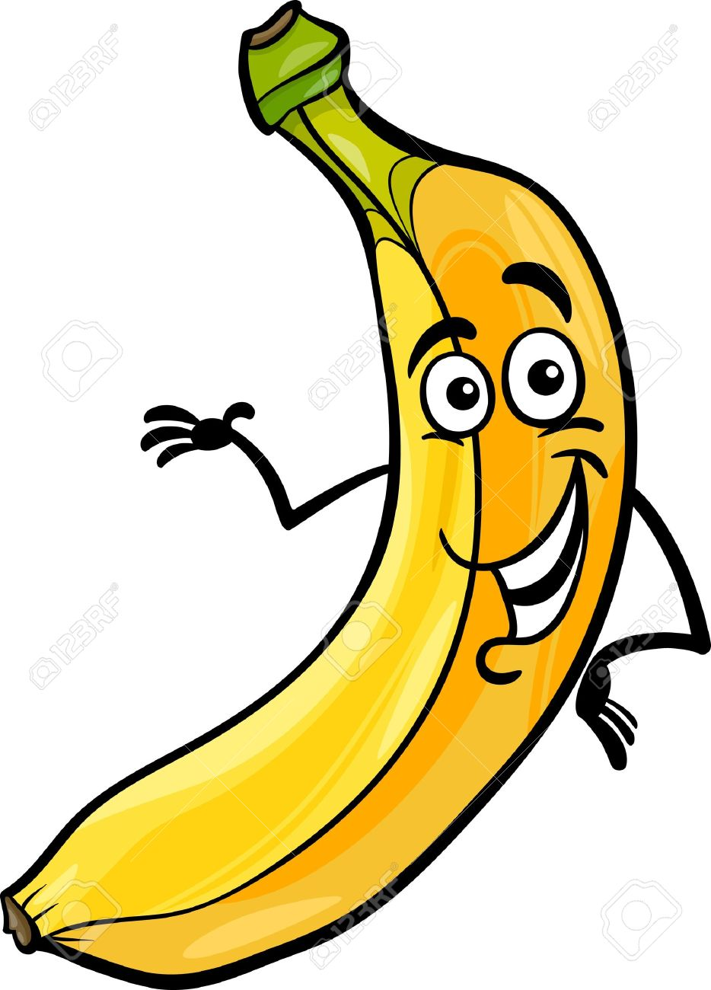

 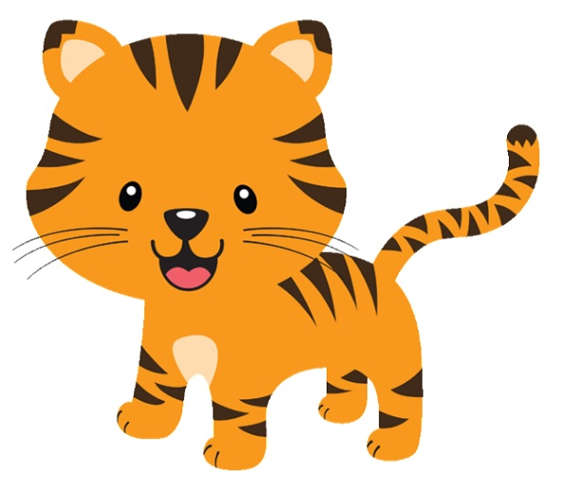

 

 

Kk Kk

Kk Kk

Kk Kk

Kk Kk

 

 

 

 