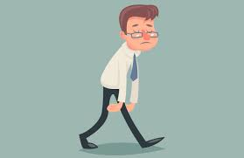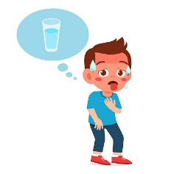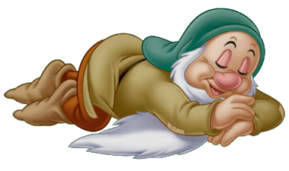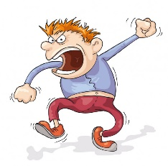
Tired Thirsty sleepy angry
Yorgun susuz uykucu kızgın

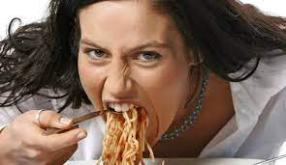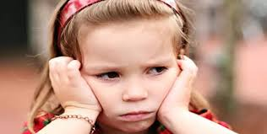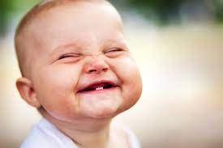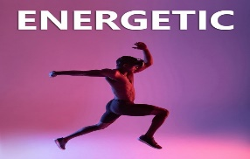
Hungry unhapy happy energetic
Aç olmak mutsuz mutlu enerjili

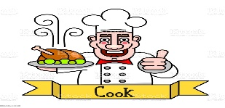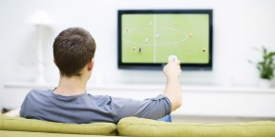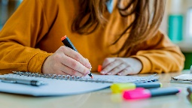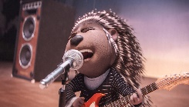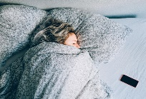
Cook Watch tv study sing sleep
Pişirmek televiyon iz. Ders çalışmak Şarkı söylemek uyumak

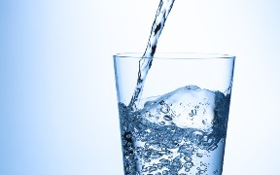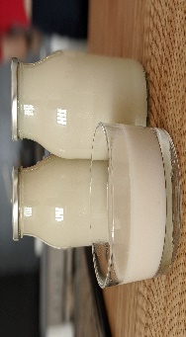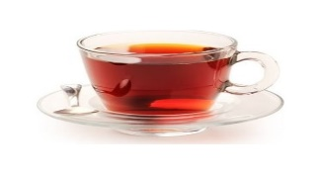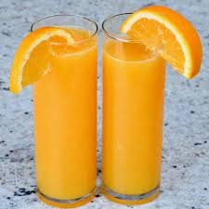
Water Milk Tea Orange juice
Su süt çay portakal suyu

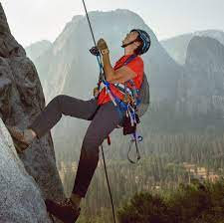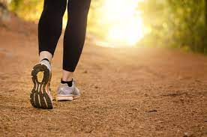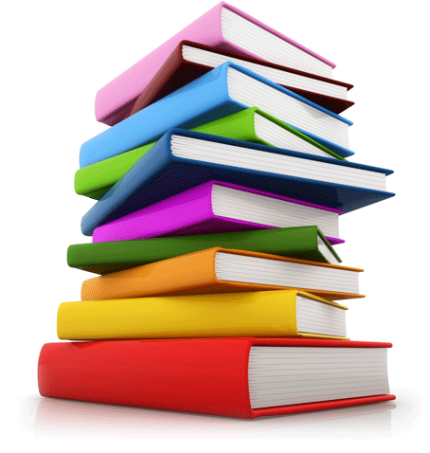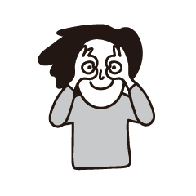
Climb(Tırmanmak) Walk (Yürümek) Book(Kitap) Look (Bakmak)
Ecenaz is drinking milk …………………………………
Fatma is watching tv…………………………………….
İbrahim is looking door………………………………….
Tunahan is climbing mountain…………………………..
Semengül is eating orange………………………………
Zeynep is walking ………………………………………
Buse is drinking tea……………………………………..
Kübra is cooking pizza…………………………………..
Eymen is studying English………………………………
Abdullah is drinking orange juice……………………….
Yavuz is happy boy……………………………………..
Mert is thirsty .She is drinking water……………………
Vedat is sleeping in the bedroom……………………….
Halil teacher singing in class……………………………………
Fatih is very energetic……………………………………

Süleyman is run fast…………………………………………
Selim is reading a book……………………………………..
Betül is riding a bike………………………………………….
Şeyma is skipping rope…………………………………….

