Ll Ll

Ll Ll

Ll Ll

Ll Ll

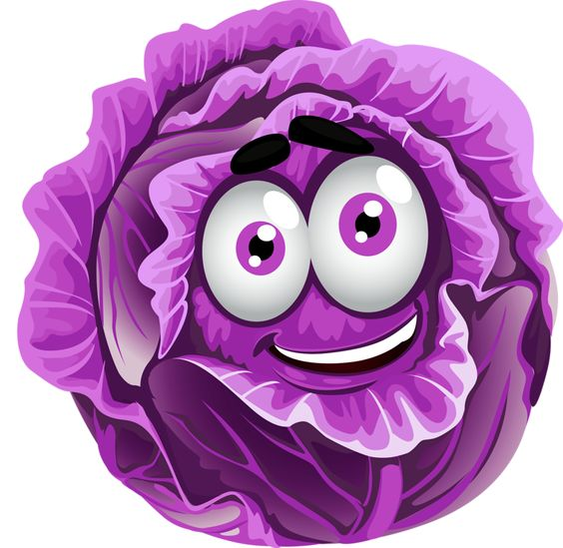 

 

Ll Ll

Ll Ll

 

 

 

 

Ll Ll

Ll Ll

 

 