Ee Ee

Ee Ee

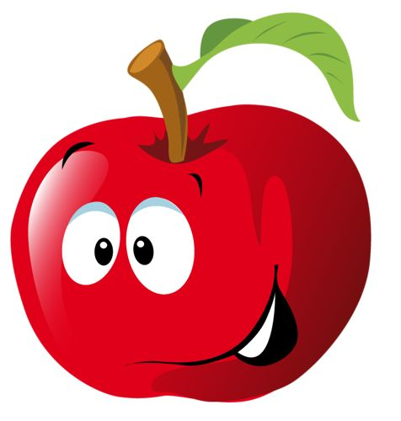 

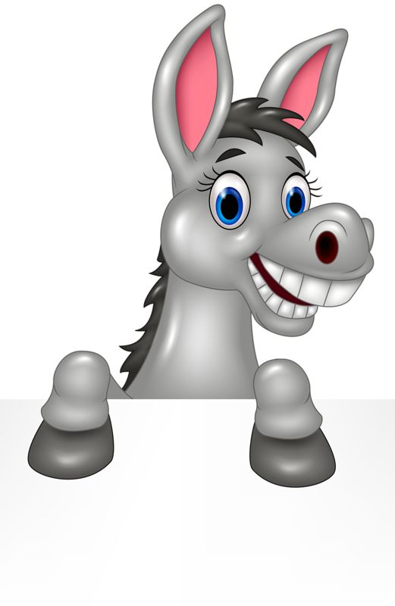 

Ee Ee

Ee Ee

 

 

Ee Ee

Ee Ee

Ee Ee

Ee Ee

 

 

 

 