Aa Aa

Aa Aa

Aa Aa

Aa Aa

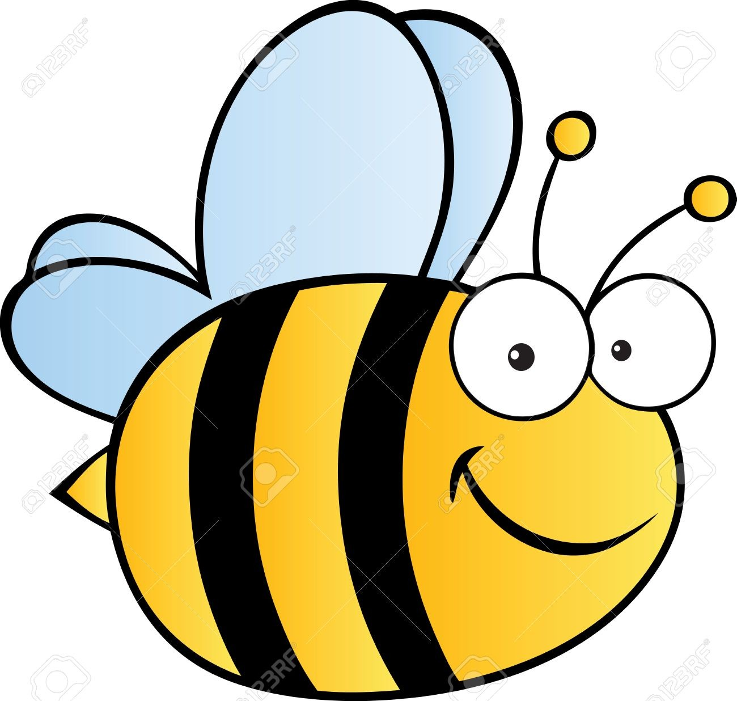 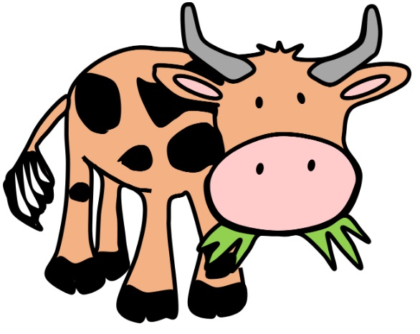

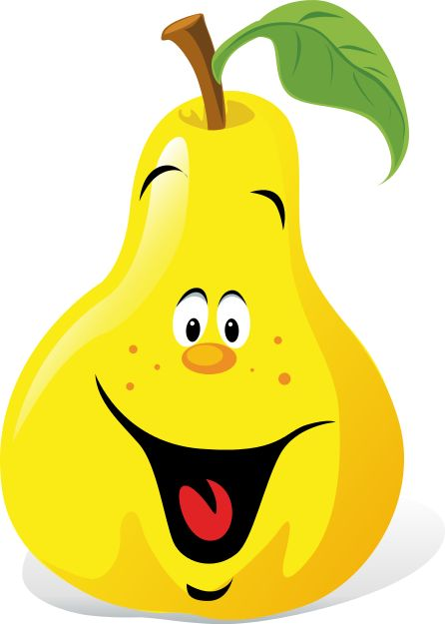 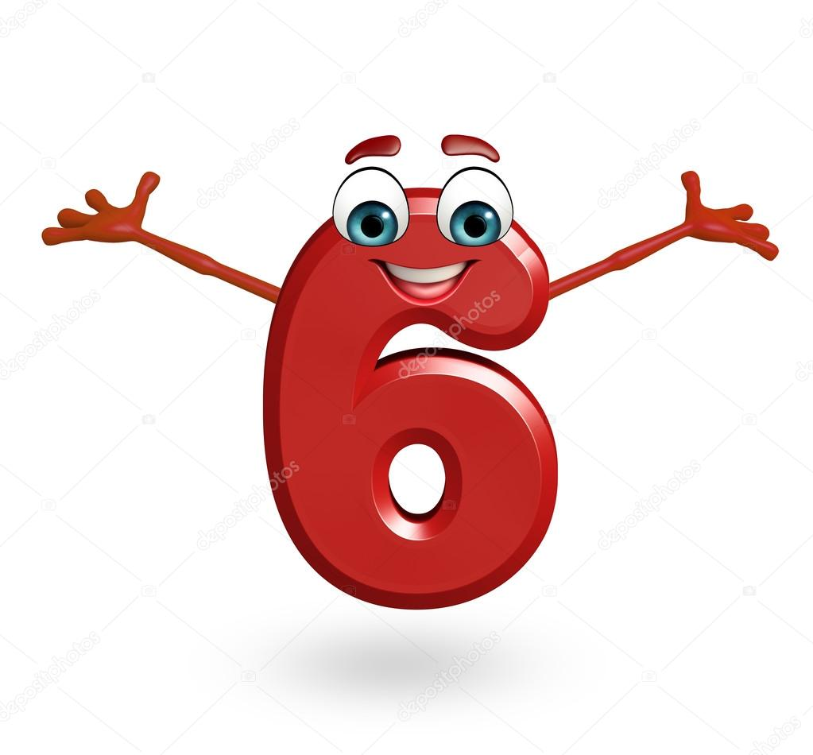

 

 

Aa Aa

Aa Aa

Aa Aa

Aa Aa

 

 

 

 